PROJECT_REPORT

Project : JusticeAI – AI-Powered Legal Assistant
for Justice and Awareness

Goal : SDG 16 – Peace, Justice, and Strong Institutions
- Target 16.3: Promote the rule of law at the national and international levels and ensure equal access to justice for all.
- Target 16.10: Ensure public access to information and protect fundamental freedoms.

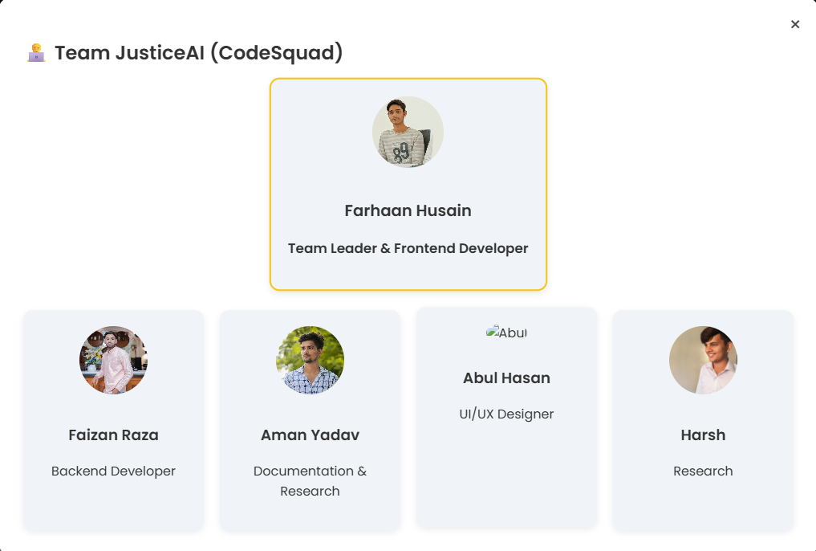
Presented By: Codesquad
Group Members:
- Farhaan Husain (Team Leader )
- Faizan Raza
- Aman Yadav
- Harsh
- Abul Hasan

INSTITUTION : ST. ANDREWS INSTITUTE OF TECHNOLOGY AND MANAGEMENT (HARYANA)

“When knowledge meets technology, justice becomes a right — not a privilege.”
— JusticeAI Team
Executive Summary:
JusticeAI is an AI-powered virtual legal assistant developed to democratize legal awareness and streamline access to basic legal support. Designed under the SDG goal “Peace, Justice, and Strong Institutions,” the system provides 24/7 support for general legal queries, offers resources for reporting injustice, and educates users about their rights using a conversational AI model.
“We built JusticeAI not to replace lawyers — but to empower the voiceless.”
— Team JusticeAI

Introduction :
Sustainable Development Goal (SDG) 16 aims to promote peaceful and inclusive
societies, provide access to justice for all, and build effective, accountable
institutions.
In a country like India, legal awareness and access to justice are
challenges faced by millions. JusticeAI leverages artificial intelligence to bridge this
gap and support legal empowerment, transparency, and institutional trust.

Problem Statement
“Despite progress in many sectors, India still grapples with corruption, violence,
weak institutions, and inadequate access to legal resources.
Citizens—especially
marginalized communities—face systemic barriers to justice, leading to a gap in
trust and effective participation in democratic processes.”

Key Issues:
- Rising violence and organized crime
- Limited access to legal aid and information
- Corruption and lack of transparency in institutions
- Exclusion of marginalized groups (women, minorities, refugees)
- Weak rule of law and unaccountable governance
Objective :
The goal of JusticeAI is to make legal help accessible to every citizen, especially
those in underserved areas. By using artificial intelligence, the platform provides
simplified legal explanations, helps file RTIs or FIRs, and builds a bridge between
people and institutions.
“Access to justice is a right. AI just makes it reachable.”

Why This Problem?
Justice is fundamental to peace and progress. Millions remain unaware of their
legal rights due to language, technical, and institutional barriers. This lack of
access fuels corruption, abuse, and inequality.
JusticeAI addresses this challenge directly by providing accessible legal knowledge through technology.

Solution:
JusticeAI Chatbot
JusticeAI is a digital legal chatbot offering clear and simplified guidance on over
100 Indian laws. The chatbot assists users in understanding laws, filing RTIs or
FIRs, and accessing nearby institutions, all in their local language.

Key Features:
- Legal Explainer: Breaks down laws into easy modules
- RTI & FIR Assistance: Step-by-step guides and tools
- Vernacular Support: Covers major Indian languages
- Low-Tech Compatibility: Works on low-end phones & poor internet
- Civic Integration: Connects with NGOs & local bodies
JusticeAI Solution Flow :
Start
↓
User opens JusticeAI
↓
User asks a legal/civic question
↓
AI processes the query
↓
Is it a basic legal question?
├── Yes → Provide law explanation + actionable steps
│ ↓
│ Show RTI/FIR guide, links, & contact info
│ ↓
│ User gains legal awareness & next steps
│ ↓
│ End
↓
└── No → Escalate to human support (future roadmap)
↓
Assist via NGO/legal expert integration
↓
End
The flowchart above depicts the overall process — from user input to legal output
— powered by NLP and structured databases.
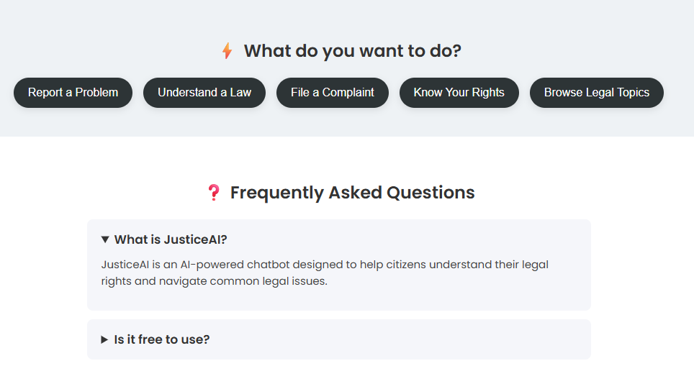
Modules & Features:
- AI Chat Interface – Interactive assistant for legal questions
- User Intent Classification – Understand whether the user wants to:
  - Know their rights
  - Report an issue
  - Get legal definitions
- Response Generation – Tailored responses with links, law summaries, or form guidance
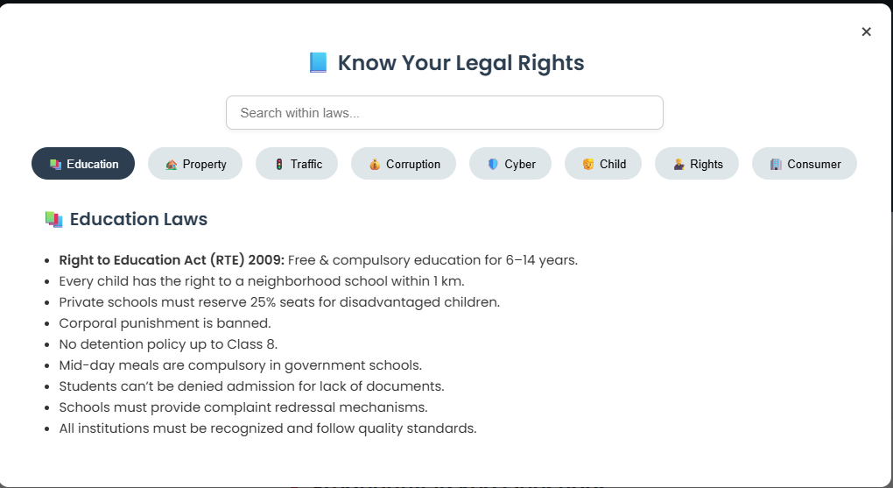
- Project Docs Section – Concept Note, Lean Canvas, and PPT
- Team Modal – Showcasing team and roles
- Legal Help Section – Category-wise law info: Property, Education, Traffic, Corruption

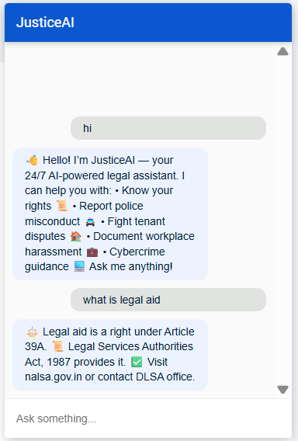
AI Model Workflow :
We move from a Dialogflow GUI to a modular NLP system:
- Input: User query (typed/text)
- Preprocessing: Tokenization, stopword removal
- Classification: Multi-label classification model (e.g., scikit-learn / fine-tuned BERT)
- Response Mapping: Using a rules engine + dynamic knowledge base
- Output: Structured legal advice, resource links, next step.

Technical Implementation
JusticeAI uses natural language processing (NLP) and legal knowledge modules to
answer queries.
The chatbot is built using scalable and secure cloud infrastructure
with multilingual support and offline compatibility.

Steps Involved:
- User sends query in natural language
- NLP module interprets the intent
- Knowledge base provides legal explanation
- Bot returns simplified legal steps or connects user to help
- Optional: human-in-the-loop for complex queries

Technology Stack :
JusticeAI is built using an efficient, scalable stack to support millions of users
across India. The platform emphasizes security, accessibility, and future
readiness.
Component | Technology Used
Frontend | HTML, CSS, JavaScript
Backend | Node.js / Flask
AI Model | OpenAI GPT (or Dialogflow CX/NLP)
Hosting | GitHub Pages
Dataset | Indian legal awareness, scraped FAQ data, simplified law explanations
Flow Engine | Rule-based + NLP hybrid

Future Roadmap:
JusticeAI aims to expand into multiple Indian languages and states, integrate with
e-courts, and partner with local NGOs and legal aid groups.
It will evolve through feedback, improving accuracy and inclusiveness.
Future Scope:
- Voice input (STT)
- Language translation (Hindi, Urdu, etc.)
- Legal document scanner/extractor
- Lawyer chatbot handoff
- Integration with legal aid NGOs

Impact :
- Immediate help for those facing injustice or confusion
- Reduced misinformation about laws
- Empowered youth and communities
- Potential integration with NGOs, helplines, or gov scheme

Conclusion
JusticeAI aligns with the core values of SDG 16: peace, justice, and strong
institutions. By simplifying complex laws and reaching underserved populations,
the platform represents a bold leap toward an inclusive, transparent, and
participatory legal system for all Indians. JusticeAI has the power to transform
citizens into empowered participants in their own governance and legal well-being.

“JusticeAI is a scalable, accessible, and socially impactful solution that bridges the gap between people and legal awareness. With further development, it can become an indispensable tool for legal inclusion and empowerment.”

“Artificial Intelligence is not just about machines — it's about making intelligence more accessible to humanity.”
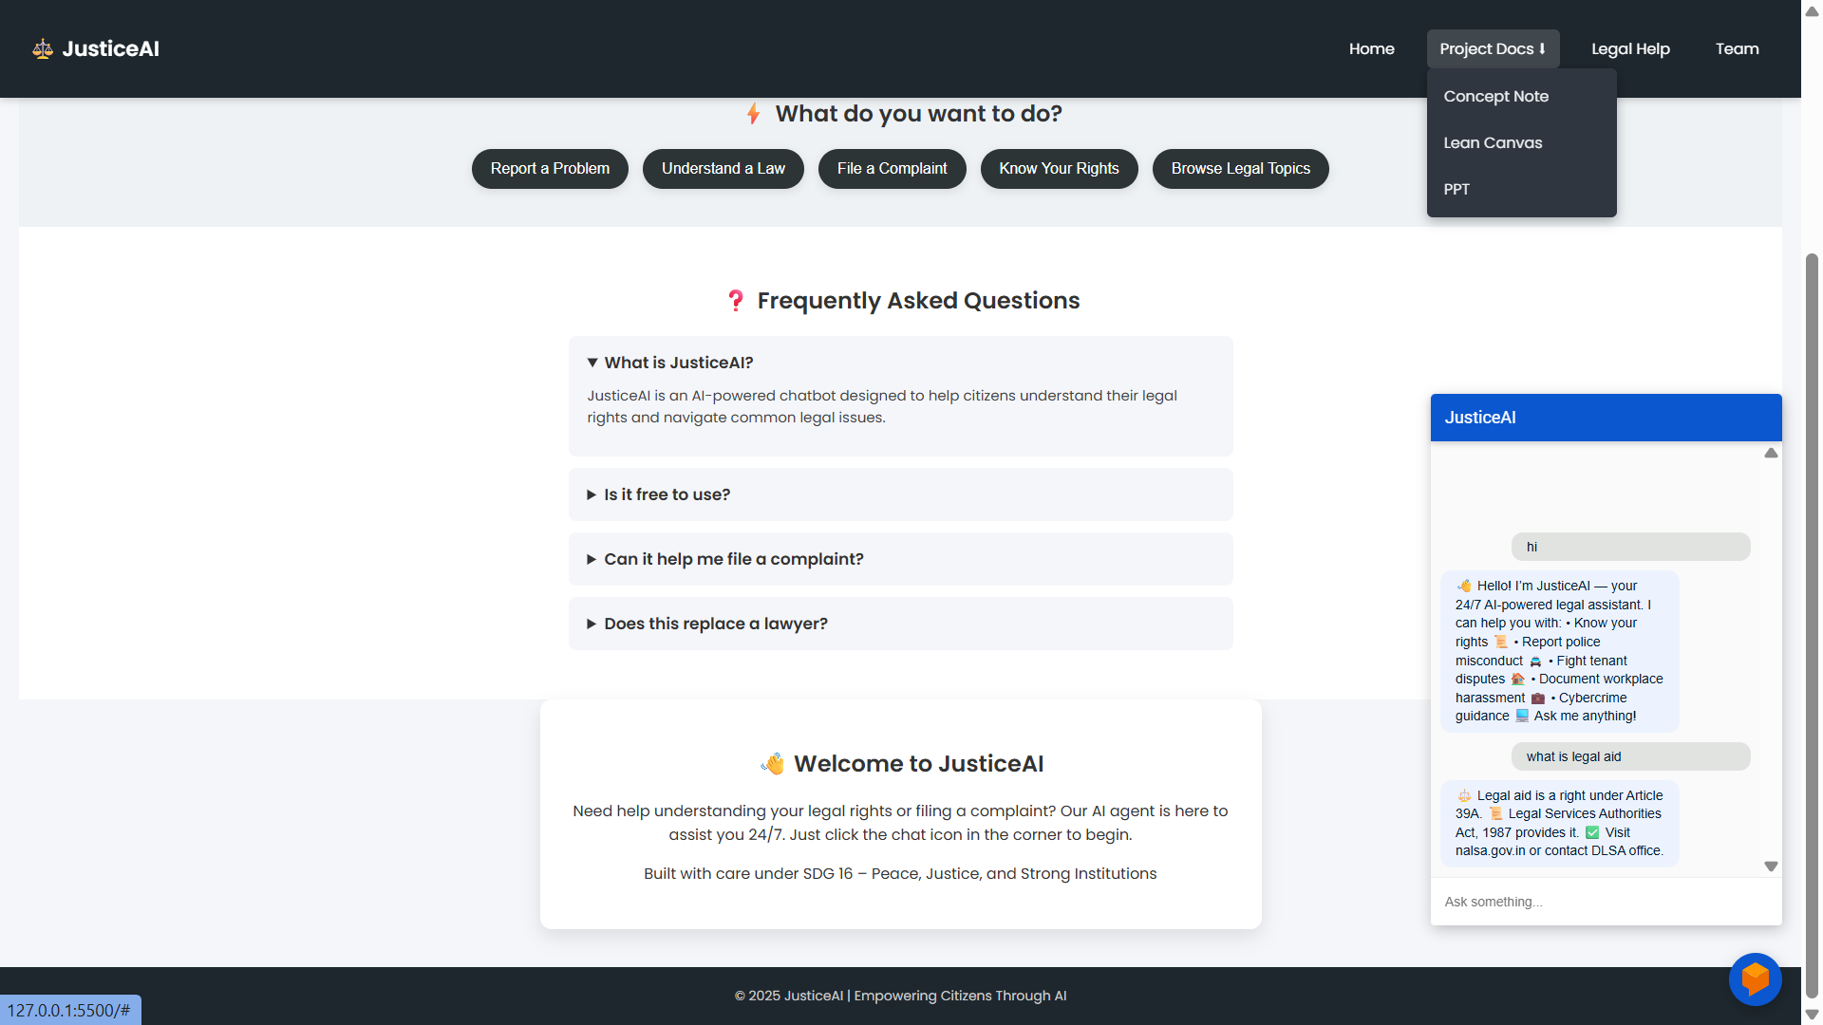
Project Overview :
